**Year 2 Semester 1 (2025)**



**Faculty of Computing**

IT2120 - Probability and Statistics Lab Sheet 10

**Lab Exercise 10 - Chi Squared Tests Week 13**

Before starting the lab sheet, you need to create a folder in your desktop and save all your working inside the folder. Set the working directory to that folder using the following command:

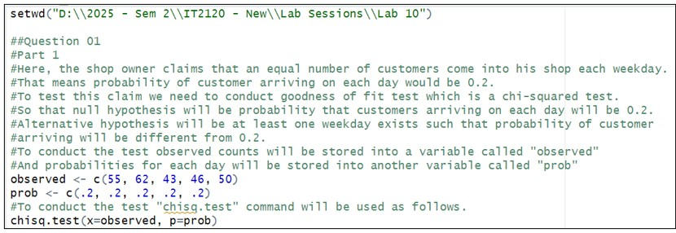setwd("paste the path of the folder")

**Eg:-** setwd("D:\\2025 - Sem 2\\IT2120\\Lab Sessions\\Lab 10")

1. A shop owner claims that an equal number of customers come into his shop each weekday. To test this hypothesis, a researcher records the number of customers that come into the shop in a given week and finds the following:

Monday: 55 customers

Tuesday: 62 customers

Wednesday: 43 customers

Thursday: 46 customers Friday: 50 customers

* 1. Conduct a suitable Chi-square test to check the claim of shop owner.
  2. Write your conclusion based on test results.

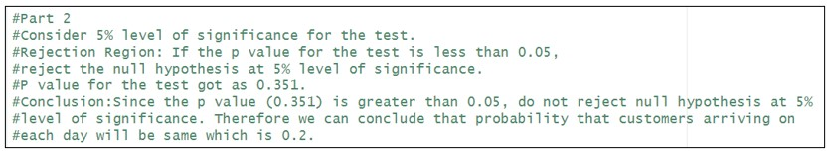

1. Consider the house tasks data set in the path, [http://www.sthda.com/sthda/ RDoc/data/housetasks.txt](http://www.sthda.com/sthda/RDoc/data/housetasks.txt) which contains contingency table with 13 house tasks and their distribution in the couple. An image of the data is displayed below:

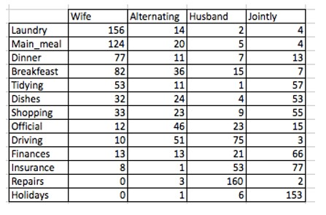

Here rows are the different tasks, values are the frequencies of the tasks done: by the wife only, alternatively, by the husband only or jointly.

* 1. Import the data into R.

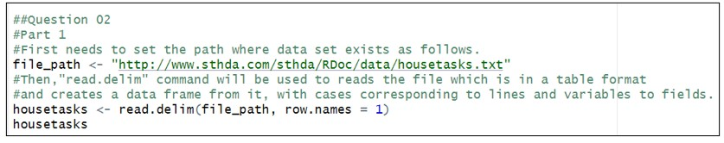

* 1. Test whether there is any association between house tasks and their distribution in the couple.

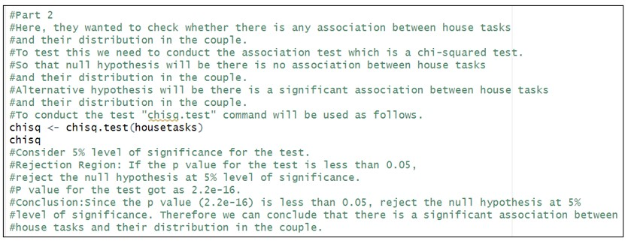

# Exercise

**Instructions**: Create a folder in your desktop with your registration number (Eg: ”IT.......”). You need to save the R script file and take screenshots of the command prompt with answers and save it in a word document inside the folder. Save both R script file and word document with your registration number (Eg: ”IT........”). After you finish the exercise, zip the folder and upload the zip file to the submission link.

1. A vending machine owner claims that customers choose the four snack types (A, B, C, D) with equal probability. To test this claim, a researcher records the number of purchases for each snack type during one week and results are given below.

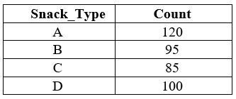

1. State the null and alternative hypotheses for the test.

Customers choose the four snack types (A, B, C, D) with equal probability.

That is, pA=pB=pC=pD=0.25

1. 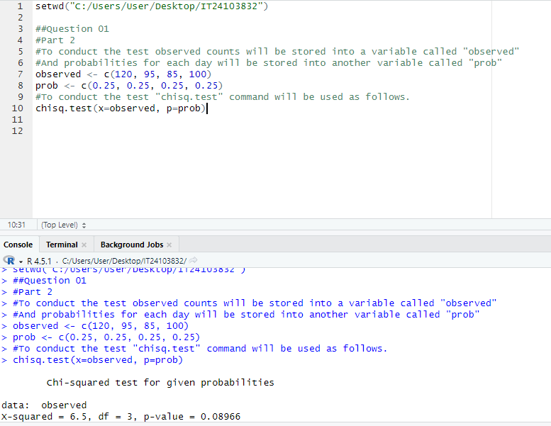 Perform a suitable chi-squared test to test the null hypothesis.

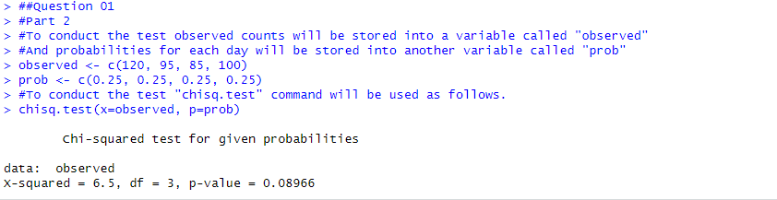

1. Give your conclusions based on the results.

* **Significance Level:** α=0.05(5%)
* **P-value:** 0.08966
* **Decision Rule:** If p-value < 0.05, reject H₀.
* **Result:** Since the p-value (0.08966) is greater than 0.05, we do not reject the null hypothesis at the 5% significance level. There is not enough evidence to conclude that customers prefer any snack type differently. Because all snack types are equally likely.